Activity 1.1.6 - Buggy Image

CSP Period 5

9/13/21

Spider Legs Program:

| # a116_buggy_image.py  import turtle as trtl  #initialize spider_turtle and draw body  spider_turtle = trtl.Turtle()  spider_turtle.pensize(40)  spider_turtle.circle(20)  num_legs = 8  leg_length = 70  angle = 360 / num_legs  spider_turtle.pensize(5)  legs_drawn = 0  while (legs_drawn < num_legs/2):  for i in [1,-1]:  spider_turtle.goto(0,20)  spider_turtle.setheading(90+(angle/2*legs_drawn+angle)*i)  spider_turtle.forward(leg_length)  legs_drawn = legs_drawn + 1  spider_turtle.hideturtle()  spider_turtle.penup()  spider_turtle.fillcolor("white")  for i in [1,-1]:  spider_turtle.goto(20*i,40)  spider_turtle.begin_fill()  spider_turtle.circle(5)  spider_turtle.end_fill()  wn = trtl.Screen()  wn.mainloop() |
| --- |

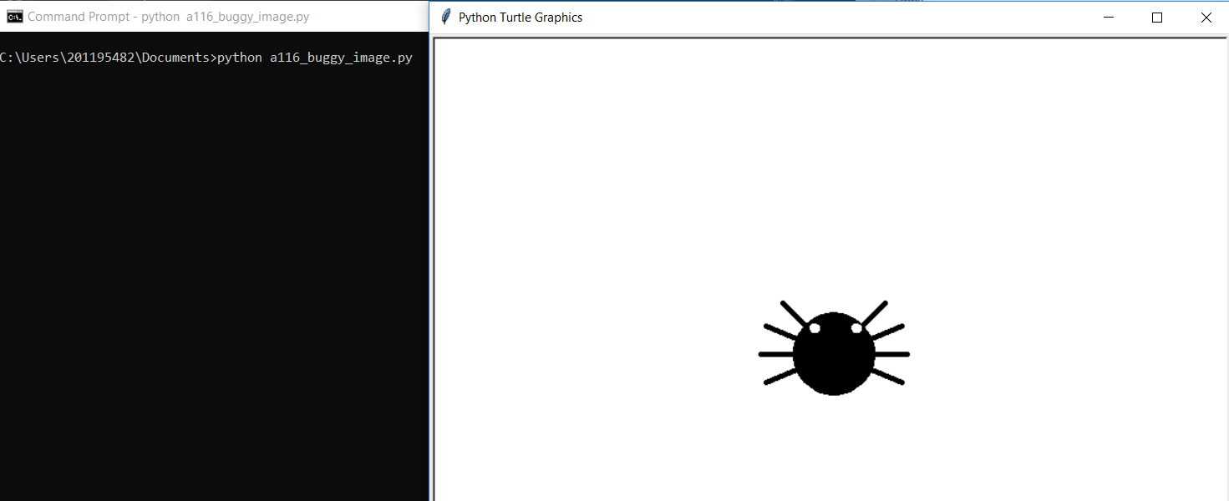

(Step 32-34): Ladybug Program:

| # a116_ladybug.py  import turtle as trtl  # create ladybug head  ladybug = trtl.Turtle()  ladybug.pensize(40)  ladybug.circle(5)  # and body  ladybug.penup()  ladybug.goto(0, -55)  ladybug.color("red")  ladybug.pendown()  ladybug.pensize(40)  ladybug.circle(20)  ladybug.setheading(270)  ladybug.color("black")  ladybug.penup()  ladybug.goto(0, 5)  ladybug.pensize(2)  ladybug.pendown()  ladybug.forward(75)  # config dots  num_dots = 1  xpos = -20  ypos = -55  ladybug.pensize(10)  # draw two sets of dots  while (num_dots <= 2 ):  ladybug.penup()  ladybug.goto(xpos, ypos)  ladybug.pendown()  ladybug.circle(3)  ladybug.penup()  ladybug.goto(xpos + 30, ypos + 20)  ladybug.pendown()  ladybug.circle(2)  # position next dots  # BUGGED LINE: xpos = ypos + 25  ypos = ypos + 25  xpos = xpos + 5  # BUGGED LINE: num_dot = num_dots + 1  num_dots = num_dots + 1  ladybug.hideturtle()  wn = trtl.Screen()  wn.mainloop() |
| --- |

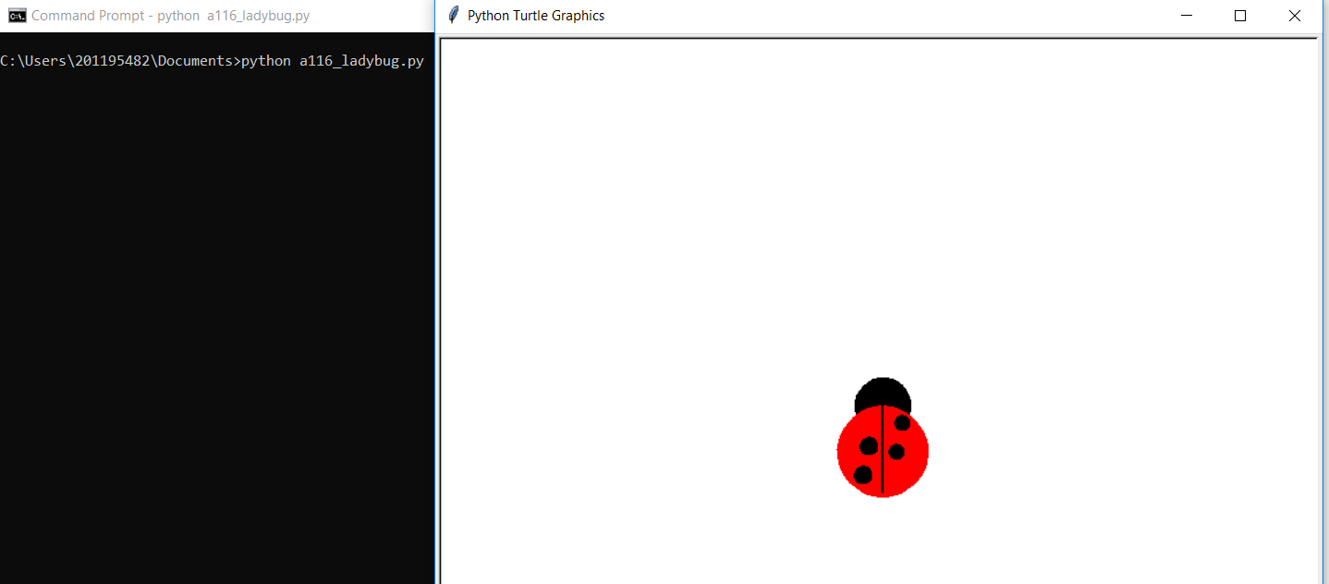

Step 35:

| # a116_ladybug.py  import turtle as trtl  ladybug = trtl.Turtle()  # create legs  num_legs = 6  leg_length = 50  angle = 360 / num_legs  ladybug.pensize(5)  legs_drawn = 0  while (legs_drawn < num_legs/2):  for i in [1,-1]:  ladybug.penup()  ladybug.goto(0,-30)  ladybug.pendown()  ladybug.setheading(90+(angle/2*legs_drawn+angle)*i)  ladybug.forward(leg_length)  legs_drawn = legs_drawn + 1  # create ladybug head  ladybug.penup()  ladybug.goto(0,0)  ladybug.setheading(0)  ladybug.pendown()  ladybug.pensize(40)  ladybug.circle(5)    # and body  ladybug.penup()  ladybug.goto(0, -55)  ladybug.color("red")  ladybug.pendown()  ladybug.pensize(40)  ladybug.circle(20)  ladybug.setheading(270)  ladybug.color("black")  ladybug.penup()  ladybug.goto(0, 5)  ladybug.pensize(2)  ladybug.pendown()  ladybug.forward(75)    # config dots  num_dots = 1  xpos = -20  ypos = -55  ladybug.pensize(10)    # draw two sets of dots  while (num_dots <= 2 ):  ladybug.penup()  ladybug.goto(xpos, ypos)  ladybug.pendown()  ladybug.circle(3)  ladybug.penup()  ladybug.goto(xpos + 30, ypos + 20)  ladybug.pendown()  ladybug.circle(2)  # position next dots  # BUGGED LINE: xpos = ypos + 25  ypos = ypos + 25  xpos = xpos + 5  # BUGGED LINE: num_dot = num_dots + 1  num_dots = num_dots + 1    ladybug.hideturtle()    wn = trtl.Screen()  wn.mainloop() |
| --- |



Steps 36-38:

| # a116_spider.py  import turtle as trtl  spider = trtl.Turtle()  spider.speed(0)  # create legs  num_legs = 8  leg_length = 50  angle = 75 / (num_legs / 2)  spider.pensize(5)  legs_drawn = 0  while (legs_drawn < num_legs/2):  for i in [1,-1]:  spider.penup()  spider.goto(0,40)  spider.setheading(i * angle * legs_drawn)  if (i == 1):  spider.left(90)  else:  spider.right(90)  spider.pendown()  spider.circle(leg_length, 120 * i)  legs_drawn = legs_drawn + 1  # create spider head  spider.penup()  spider.goto(0,0)  spider.setheading(0)  spider.pendown()  spider.pensize(40)  spider.circle(5)    # and body  spider.penup()  spider.goto(0, 30)  spider.color("black")  spider.pendown()  spider.pensize(40)  spider.circle(20)  spider.setheading(270)  spider.color("black")  spider.penup()  # create eyes  spider.setheading(-90)  spider.pencolor("purple")  spider.fillcolor("purple")  spider.pensize(1)  for i in [1,-1]:  spider.goto(10*i, -10)  spider.begin_fill()  spider.pendown()  spider.circle(3)  spider.end_fill()  spider.penup()  spider.hideturtle()    wn = trtl.Screen()  wn.mainloop() |
| --- |

